

**MINI PROJECT REPORT ON PROJECT**

**FACE RECOGNITION**

**ATTENDACE SYSTEM**

**BACHELOR OF COMPUTER APPLICATION**

**By**

Yash Gupta

22201020082

**SUBMITTED**

**TO**

Lokesh Meena

IBM Trainer



**DEPARTMENT OF COMPUTER APPLICATIONS**

**UNITED UNIVERSITY,**

**RAWAPUR, PRAYAGRAJ, UTTAR PRADESH-211012**

**(2023-24)**

**Project Certificate**

This is to certify that the mini project report entitled Face Recognition Attendance System submitted to United University, in partial fulfillment of the requirement for the award of the degree of BACHELOR OF COMPUTER APPLICATIONS (BCA), is original work carried out by myself Mr. Yash Gupta with enrolment no. UU222010232 Under the Supervision of Mr. Lokesh Meena. The matter embodied in this project is genuine work done by myself and has not been submitted whether to this University or to any other University / Institute for the fulfillment of the requirement of any course of study.

Date:

Signature of the Student

Yash Gupta

22201020082

UU222010232

Verified by the Guide

**Acknowledgement**

This Major Project is the result of contribution of many minds. I would like to acknowledge and thank my mini project guide Lokesh Meena for his valuable support and guidance. He guided me through the process from conception and till the completion of this project. I would also like to thanks my all my faculties, lab staff members.

I am very thankful for the open-handed support extended by many people. While no list would be complete, it is my pleasure to acknowledge the assistance of my friends who provided encouragement, knowledge and constructive suggestions.

Signature of the Student

Yash Gupta

22201020082

UU222010232

**ABSTRACT**

The progress in technology has changed various aspects of people's lives, from indulgence in attendance regulation activities to the job field. Facial recognition technology is being used in this work to create a system for automatic attendance capturing that is connected to a MySQL database. The main feature of this system is to simplify the attendance process, thereby cutting down on unnecessary costs and get the work done on time.  
  
The project's methodology targets the utilization of OpenCV and face_recognition libraries and Python to detect and recognize the faces captured by the webcam or a camera. The identified faces are subsequently matched with a database of known persons to be able to record their presence. The main achievements of the project are realization the state-of-the-art face recognition algorithm and supporting the system on MySQL database for storage and management purposes.  
  
In a nutshell, the automated attendance system is a potential alternative to the primitive ways of using attendance trackers that have been in practice in schools and colleges. The elimination of manual data entry as well as the reduction in the risk of mistakes improves the system’s productivity and accountability in a way that is efficient. The successful implementation of the system is an important signal of the high potential of technology-based solutions to automate the basic processes and increase business efficiency.

**INTRODUCTION:**

Establishing the attendance regulations is one of the crucial things which impact both education institutions and individual enterprises. By design, this activity was done using old fashioned approach including the use of paper registers and electronic systems needing data entry by hand. On the other hand, these techniques have got their own shortcoming. They are time-consuming, laden with errors, as well as denying the feature of up-to-date monitoring. The advent of engineering-based attendance systems which is powered by face recognition issues would thereby be solved and an equally effective, precise and reliable solution would provide.  
  
The project ideas arise from the vision that the technological progress made by face recognition can be utilized to transform attendance management and make it automatic. The objective is to involve face recognition together with MySQL database in order to design a system that helps you to supervise attendance while the accuracy is increased besides providing real time monitoring. The following section will provide a clear explanation of the tasks to be performed and the methods used in carrying out the project for anticipated outcomes.

In the previous paragraph, we outlined the established challenges in a manual attendance management system, and it is through the use of automatic systems that the challenges are addressed. We have additionally presented a short overview of the project's goals and the type of technologies it intends to use. It is here that we establish the basis for in-depth investigation of the subject in the following chapters.

**MOTIVATION:**

The reason for me to commence this project was the dated conventional attendance tracking process, which clearly does not meet the exigency of an efficient and trustworthy attendance management solution. Manual registering procedures are time-consuming, error-prone, unequipped with real- time monitoring and are lacking in many aspects. This may lead to a lower accuracy rate, more inefficiencies as well as discrepancies in attendance records which could be very exhaustive during payroll calculation or as it relates to cases of academic misconduct.  
  
Moving on now, the above trend has quickened the adoption of automated attendance tracking systems that can effectively meet the diverse needs of workplaces in a wide range of work environments and attendance policies. The employed standard methods will be hard to adapt to remote labor and there is a possibility they to be inefficient in supervising and tracking the modern workforce.  
  
Through the implementation of face recognition technology, the major issue concerning the present systems; constant irregularities and inefficiency can be addressed. Apart from identification being done faster, with greater accuracy and in real-time, the face recognition technique also provide higher effectiveness than the traditional methods. Through automating the attendance-tracking process, companies can improve administration and accuracy hence increase productivity generally.

**WHY THIS PROJECT?**

The decision to undertake this project was influenced by several factors, including the increasing demand for automated attendance tracking solutions, advancements in face recognition technology, and the potential benefits it offers for organizations and institutions. The following reasons highlight why this project is both relevant and timely:

* Efficiency: Manual attendance tracking methods are time-consuming and labour-intensive, requiring significant administrative effort to maintain accurate records. By automating the attendance tracking process, organizations can save time and resources, allowing staff to focus on more strategic tasks.
* Accuracy: Face recognition technology offers a high level of accuracy in identifying individuals, reducing the risk of errors associated with manual data entry or identification. This ensures that attendance records are more reliable and reflective of actual attendance patterns.
* Real-time Monitoring: Unlike traditional methods, which rely on periodic updates or manual reconciliation, automated attendance systems provide real-time monitoring capabilities. This allows organizations to track attendance instantly and respond promptly to any deviations or anomalies.
* Scalability: Automated attendance systems are scalable and adaptable to various organizational sizes and structures. Whether deployed in a small classroom or a large corporate environment, these systems can accommodate different attendance policies and volumes with ease.
* Integration: By integrating with existing systems such as payroll, scheduling, and HR management software, automated attendance systems can streamline workflows and enhance overall efficiency. This seamless integration ensures that attendance data is synchronized across all relevant systems, eliminating the need for manual data entry or reconciliation.

**OBJECTIVES AND GOALS:**

The major aim of this project is the creation of an automated system for attendance based on face recognition technology with MySQL data base inclusion as its component. The following goals outline the specific outcomes and deliverables expected from the project:

* Develop Face Recognition System: Develops and implements face recognition system that will be able to easily distinguish individuals with high level of accuracy by examining facial features in real setting. That involves the image preprocessing and the facial feature extraction, which serves as the basis for the face verification against gallery images of already interviewed persons.
* Integrate with MySQL Database: Develop the MySQL as a database to record the attendance and as well as insure the security of records too. This involves the creation of a suitable data schema, lipofidon of CRUD (Create, Read, Update, Delete) operations, and data integrity and security warranty.
* Ensure Scalability and Reliability: Make sure to provide the attendance system with a capacity that is scalable, expanding with the load and circumstances. This task entails the performance optimization of the system, concurrency management for the smooth execution, as well as the implementation of the error management mechanisms to avoid suspension.
* Provide User-friendly Interface: Design the interface of the attendance system to meet end-users' needs by permitting them to register subjects, look at attendance records, and build reports with ease. This involves a setup of ergonomic user interfaces and bring aboard of the feedback from the end-users to make the usability and accessibility more effective.
* Ensure Data Security and Privacy: Little about the application is better than guaranteeing security and privacy of attendance data that is saved in the MySQL database. Here, we mean a process of encryption and implementing of access restrictions as well as respecting relevant data protection laws.

**BACKGROUND:**

As far as history speaks, attendance management has been a long-standing basic aspect of organizational management which teems with different activities and processes aimed at tracking and monitoring the presence of people in predefined settings. The correct recording of attendance is of great significance to various settings like educational institutions, corporate bodies and government agencies as it helps generate the necessary reports for account purpose, compliance and employee performance evaluation.

Attendance monitoring was once done the traditional way where sign-in sheets of paper, sign-in registers or those electronic systems which needed manual input were the common way for tracking attendance. The followings ones brought a lot to the medical practice, but they were very labor-intensive, and had a margin of error. Also, they did not have a real-time monitoring capability. The result was the fact of the having of inaccurate records, administrative burden and problems concerning of matters of compliance and accountability.

The development of technology is the major reason for the radical shift in approach to the attendance management, which more often than not, provides more trustworthy and faster solutions for tracking attendance.

**TOOLS and PLATFORM:**

The development of the automated attendance system relies on a combination of software tools and platforms to facilitate various tasks and functionalities. The following tools and platforms are essential components of the project:

* OpenCV: OpenCV (Open-Source Computer Vision Library) is an open-source computer vision and machine learning software library that provides various tools and algorithms for image processing, object detection, and facial recognition. OpenCV is used in this project to capture images from a webcam or camera, preprocess images, and perform face detection and recognition tasks.
* face_recognition Library: The face_recognition library is a Python module that provides simple and easy-to-use APIs for face detection, recognition, and manipulation. Built on top of OpenCV and dlib (a C++ library for machine learning), face_recognition offers high-level abstractions for common face-related tasks, making it ideal for rapid prototyping and development.
* MySQL Database: MySQL is an open-source relational database management system (RDBMS) that provides a scalable, high-performance, and reliable platform for storing and managing structured data. In this project, MySQL is used to create and manage a database for storing attendance records, student or employee information, and related metadata.
* Python Programming Language: Python is a versatile and widely-used programming language known for its simplicity, readability, and extensive ecosystem of libraries and frameworks. Python is the primary programming language used in this project for developing the face recognition system, integrating with the MySQL database, and implementing the user interface.

**HARDWARE REQUIREMENTS:**

The successful operation of the automated attendance system relies on the following hardware components:

* Computer: A computer or laptop with sufficient processing power and memory to run the face recognition algorithms and database operations smoothly. The computer should meet the minimum system requirements for running the required software tools and libraries.
* Webcam or Camera: A webcam or camera capable of capturing high-quality images is essential for the face recognition process. The camera should have adequate resolution, frame rate, and low-light performance to ensure accurate face detection and recognition in various lighting conditions.
* Internet Connectivity: Internet connectivity is required for accessing online resources, downloading software updates, and synchronizing data with remote servers. A stable and high-speed internet connection is recommended to minimize latency and ensure seamless operation of the attendance system.

**SOFTWARE PLATFORMS:**

1. **Frontend**:
   * The frontend of the attendance system is primarily implemented within the Python environment using libraries like OpenCV and face_recognition for capturing images, performing face detection, and displaying the user interface.
   * While the project does not involve traditional web-based interfaces or desktop GUI frameworks like HTML, CSS, JavaScript, PyQt, or Tkinter, it may include graphical overlays or visualizations within the OpenCV window for interaction with users.
2. **Backend**:
   * The backend logic of the attendance system is implemented using Python programming language.
   * Libraries such as OpenCV, face_recognition, and MySQL Connector are used for processing requests, managing data, and coordinating communication between different components.
   * The backend handles tasks such as face recognition, database operations, and attendance marking.
3. **Web Server**:
   * As the project does not involve web-based interfaces or traditional web servers like Apache HTTP Server or Nginx, the concept of a dedicated web server is not directly applicable.
   * However, if the project were to be extended to include web-based components in the future, it could utilize web servers like Apache HTTP Server or Nginx to host and serve the frontend interfaces.
4. **Database Server**:
   * The project integrates with a MySQL database server for storing and managing attendance records.
   * The MySQL Connector library is used in Python to establish a connection with the MySQL database server, perform CRUD operations (Create, Read, Update, Delete), and ensure data integrity and security.

Overall, the software platforms utilized in the project primarily revolve around Python programming language, OpenCV, face_recognition library, and MySQL database server for implementing the face recognition-based attendance system. While the project does not include traditional frontend or web server components, it focuses on the integration of face recognition technology with database management for efficient attendance tracking.

**DIAGRAMS OF PROJECT:**

* **UML Diagrams:**
  + Class UML Diagram:

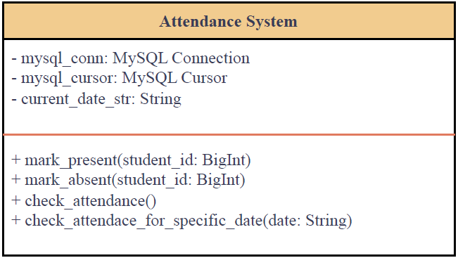

Attendance System: This class manages the overall attendance system. It interacts with the database to mark attendance, check attendance, etc.

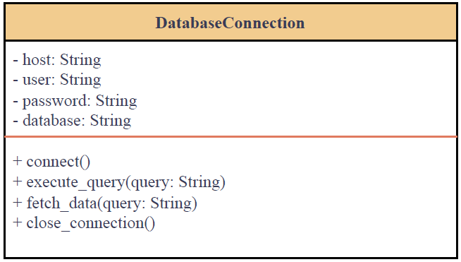

Database Connection: This class handles the connection to the MySQL database. It provides methods to connect, execute queries, fetch data, and close the connection.

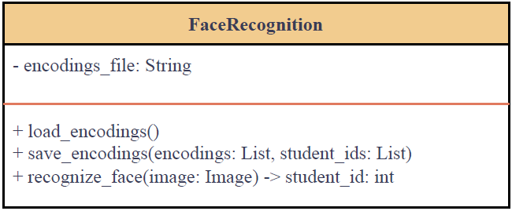

Face Recognition: This class handles the facial recognition functionality. It loads and saves face encodings, and recognizes faces in images.

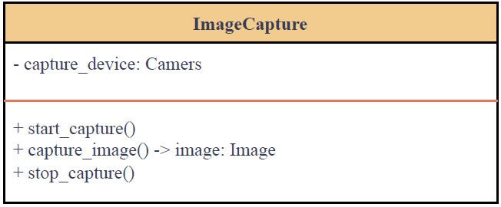

Image Capture: This class manages the image capture functionality. It interacts with the camera to start/stop capturing images and captures images.

* + Sequence UML:

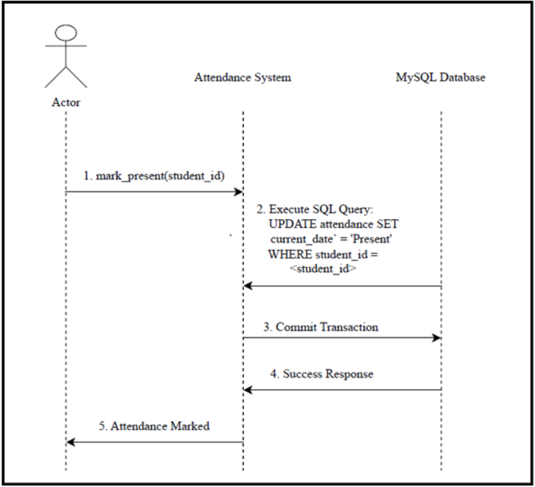

1. Actor: Represents the external entity (user) interacting with the system.
2. Attendance System: Represents the main system handling attendance-related operations.
3. MySQL Database: Represents the database where attendance data is stored.
4. Numbers: Represent the sequence of steps in the interaction.

* **DFD (0-level and 1-level)**
  + 0-level:

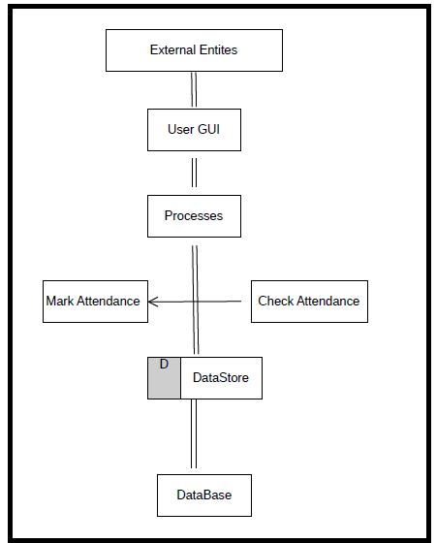

* External Entities: Represent entities outside the system boundary that interact with the system. In this case, the user and any external interfaces or systems.
* User GUI: Represents the graphical user interface through which the user interacts with the system.
* Processes: Represent the major functions or processes within the system. In this case, marking attendance and checking attendance.
* Data Store: Represents where data is stored within the system. In this case, the database where student information and attendance records are stored.
* Database: Represents the database management system where student data and attendance records are stored.
* 1-level:

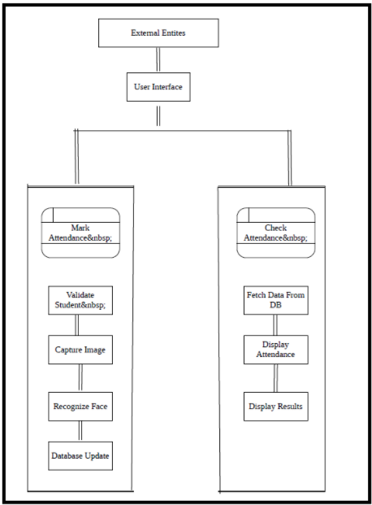

* External Entities: Represent entities outside the system boundary that interact with the system. In this case, the user interacting with the system through the user interface.
* User Interface: Represents the interface through which the user interacts with the system.
* Processes: Represent the major functions or processes within the system, which are further broken down into sub-processes.
* Sub-Processes:
  + Mark Attendance:
    - Validate Student: Verify if the student is valid.
    - Capture Image: Capture the image of the student.
    - Recognize Face: Recognize the face in the captured image.
    - Update Database: Update the attendance record in the database.
  + Check Attendance:
    - Fetch Data From DB: Retrieve attendance data from the database.
    - Display Attendance: Display the attendance data to the user.

**APPLICATIONS:**

Screenshots of the attendance system's user interface and functionality provide visual representations of its features and usage scenarios:

* **User Interface Screenshots**:
* Camera Frame:



* Functions:

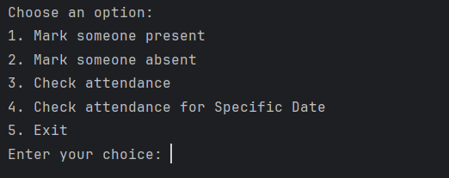

* **Functionality Demonstrations**:

Test Case 1:

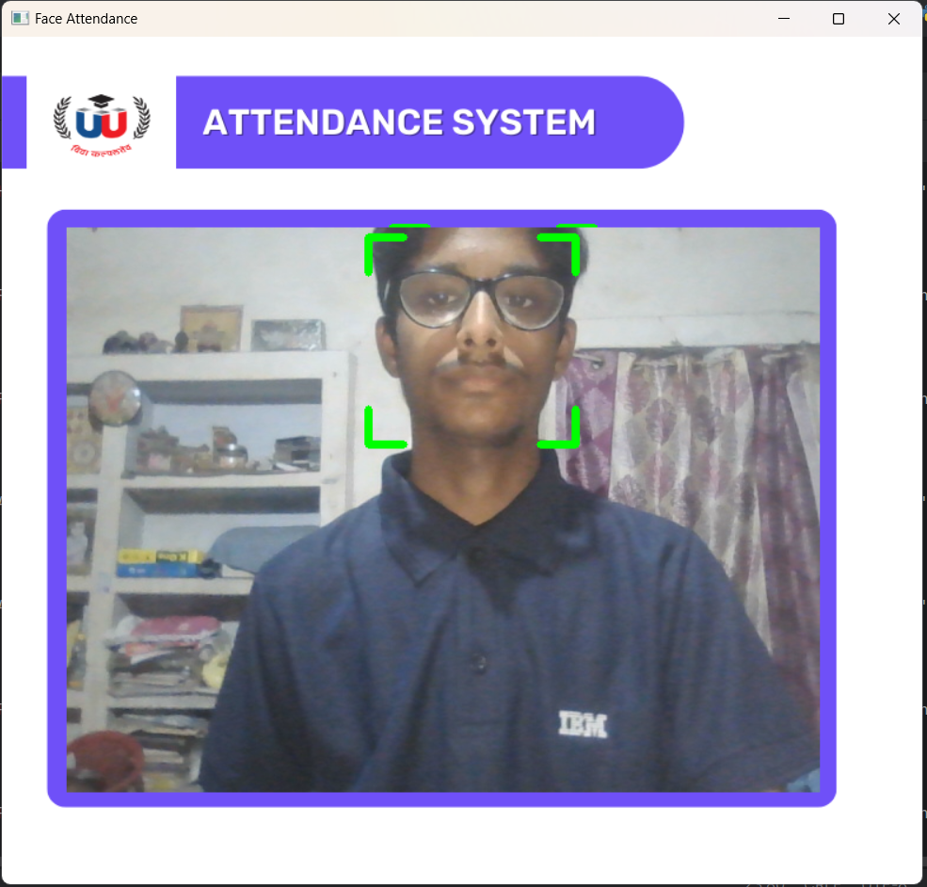

Output:

Accuracy: 0.4616731533582661

22201020082

Student Details: (22201020082, 'YASH GUPTA', 'BCA_IBM')

Test Case 2:

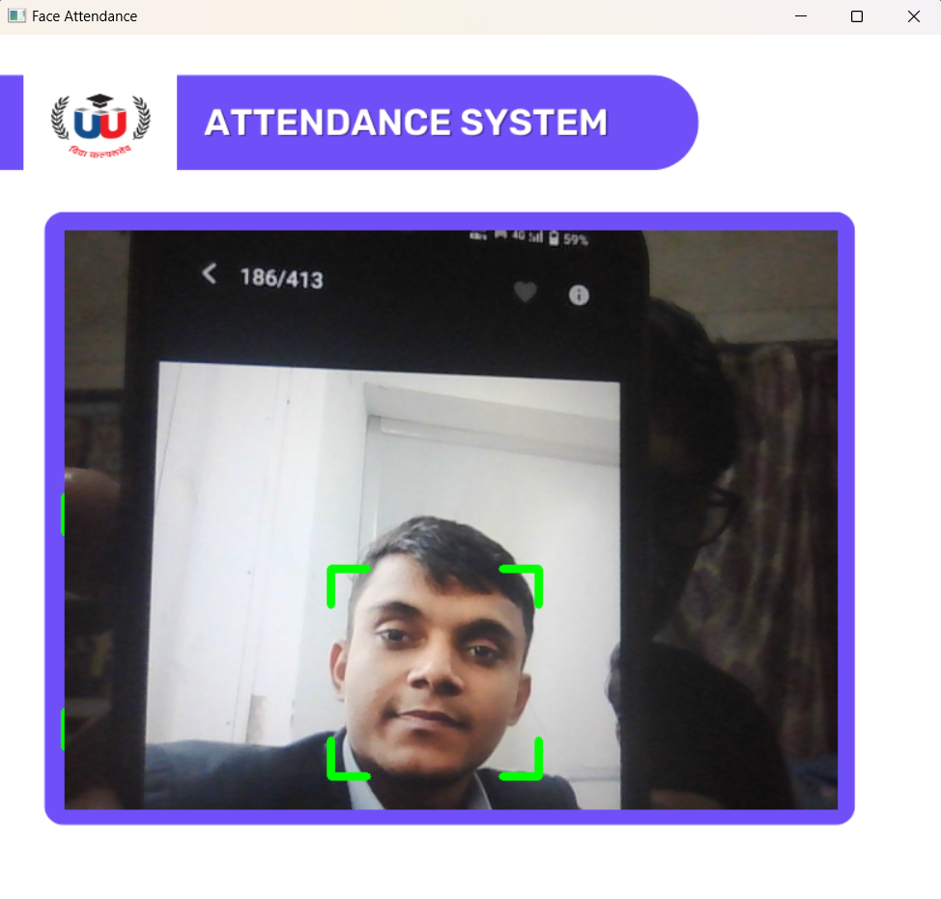

Output:

Accuracy: 0.7925109202363408

22201020063

Student Details: (22201020063, 'SACHIN PATEL', 'BCA_IBM')

Test Case 3:

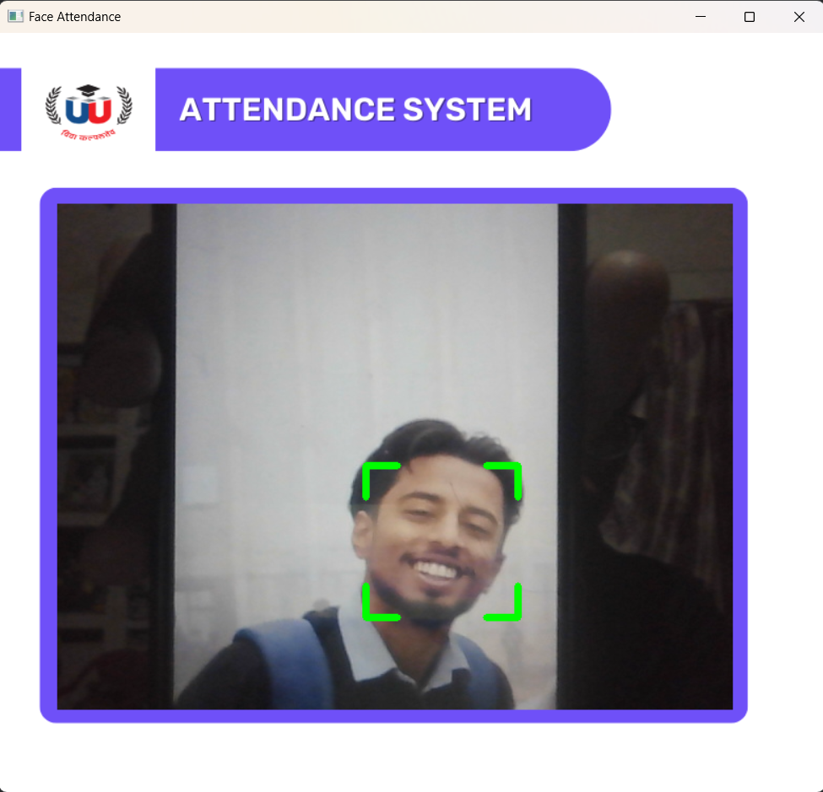

Output:

Accuracy: 0.5123907383680685

22201020080

Student Details: (22201020080, 'WANSH SRIVASTAVA', 'BCA_IBM')

Attendance Record:

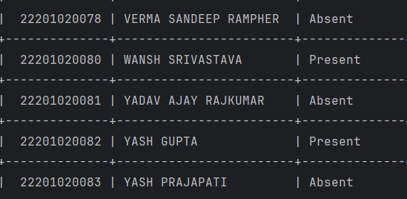

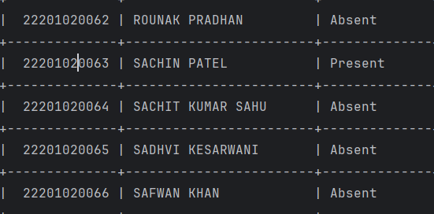

**Manual Functions Testing:**

1.Mark Present:

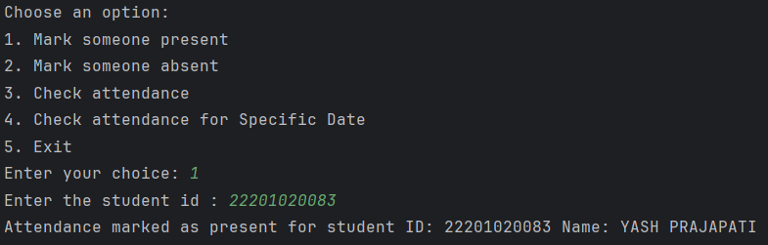

2.Mark Absent:

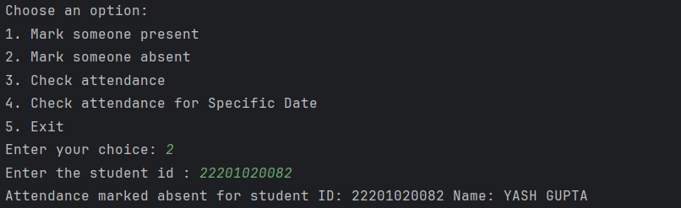

3.Check Attendance:

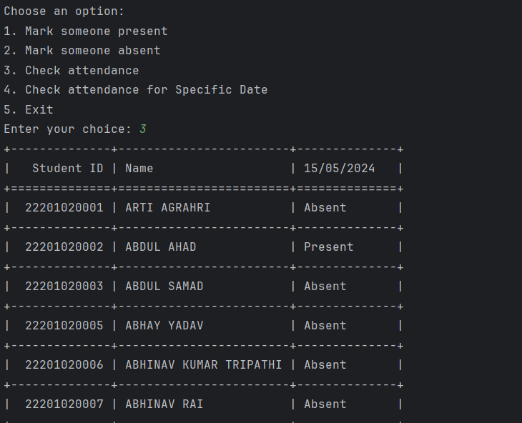

4.Check Attendance for specific date:

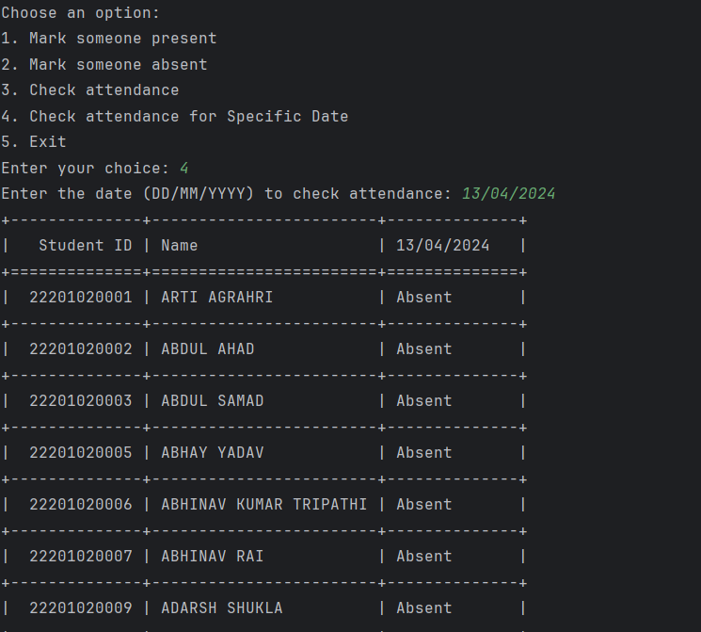

5.Exit:

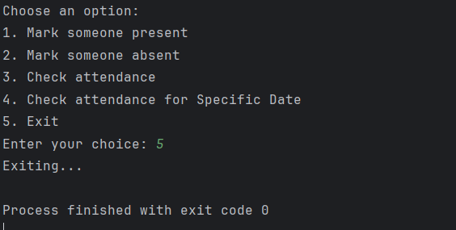

**FUTURE OF THE PROJECT:**

The future of the automated attendance system holds several opportunities for further enhancement and development:

* Enhanced Features: Future iterations of the attendance system may include additional features such as facial expression recognition, multi-factor authentication, and predictive analytics for identifying attendance patterns and trends.
* Integration with Biometric Authentication: Integration with other biometric authentication methods such as fingerprint recognition, iris scanning, or voice recognition can enhance the security and reliability of the attendance system, providing multiple layers of authentication.
* Mobile Applications: Developing mobile applications for iOS and Android platforms allows users to access the attendance system from anywhere, enabling remote attendance tracking and management on-the-go.
* Cloud Deployment: Cloud deployment options such as AWS (Amazon Web Services), Microsoft Azure, or Google Cloud Platform offer scalability, flexibility, and reliability for hosting the attendance system, allowing organizations to scale resources as needed and ensure high availability.
* Machine Learning and AI: Leveraging machine learning and artificial intelligence techniques for facial recognition and attendance prediction can improve the accuracy and efficiency of the attendance system, enabling proactive decision-making and automated attendance management.

**REFERENCES: -**

The development and implementation of the automated attendance system draw insights from various reputable sources in the fields of attendance management, face recognition, and database systems. The following references provide valuable information and guidance:

* Academic Research Papers: Scholarly articles and research papers on topics related to attendance management, biometrics, computer vision, and machine learning contribute to the theoretical foundation of the project. These papers offer insights into cutting-edge technologies, methodologies, and best practices in attendance tracking and biometric authentication.
* Books and Textbooks: Literature on attendance management systems, face recognition algorithms, and database systems serves as a comprehensive resource for understanding key concepts, principles, and techniques relevant to the project. Books authored by experts in the field provide in-depth knowledge and practical insights into the design, development, and implementation of automated attendance systems.
* Online Documentation and Tutorials: Online documentation and tutorials for software tools and libraries such as OpenCV, face_recognition, and MySQL Connector offer practical guidance and reference materials for implementing specific functionalities within the project. These resources provide step-by-step instructions, code examples, and troubleshooting tips for leveraging the capabilities of various software platforms and libraries.
* Official Documentation and Specifications: Official documentation and specifications for relevant technologies and standards, including Python programming language, OpenCV, face_recognition library, and MySQL database server, serve as authoritative references for understanding the functionalities, APIs, and usage guidelines of these tools and platforms. Adhering to official documentation ensures consistency, compatibility, and reliability in the implementation of the project.
* Peer-Reviewed Journals and Articles: Peer-reviewed journals and articles focusing on biometrics, computer vision, machine learning, and attendance management offer insights into the latest research developments, methodologies, and advancements in the field. These sources provide empirical evidence, case studies, and experimental results that validate the effectiveness and feasibility of automated attendance systems based on face recognition technology.

Proper citation and acknowledgment of these references contribute to the credibility, integrity, and scholarly rigor of the project's findings and recommendations. By building upon the knowledge and expertise documented in these sources, the project establishes a solid foundation for further research, innovation, and development in the domain of attendance management and biometric systems.